Step 0 Intake + Interview Filing Status, Dependency

Interview Notes: (See also: General Notes)
- Helen has not lived with her husband, Peter Rosemont, for several years. His SSN is 782-00-1234. Helen is not claiming an exemption for Peter.
- Peter did not itemize last year nor will he be itemizing this year.
- Helen rents a home and pays $1,400.00/month rent.

Documents:
791-xx-yyyy
Helen E. Rosemont
Helen E. Rosemont

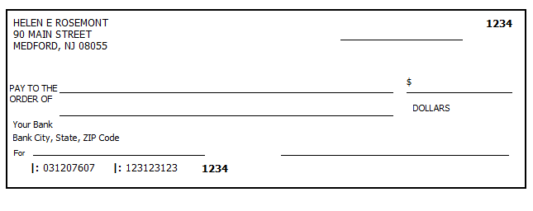

Step 1 Basic Information

TP Form / Note | TS Screen | Notes
SS Card | Start a New 2018 Tax Return  Available Taxpayer Profiles | Ignore the Profiles  Select “Enter Social Security Number” at the bottom of the screen  Enter the TP SSN twice and “Start Return”
Intake Sheet  I- Note 1 | What is your filing status? | TS Answer: Filing Status: Married Filing Separate  “Continue”  TS: Do not check “Check here if the Spouse lived with the Taxpayer at any time during the year”.  TS: “Continue”
SS Card  Intake Sheet  I-Note 1 | Personal Information  Taxpayer Information  Address & Phone Number | TS: Enter all information using “Caps Lock”  Hint: Use Name and SSN from SS card. (Not Intake Sheet)  Hint: SSN format YYY-00-0752  TS: Birth date can be entered using drop down menu or filling in the field.  TS: Check any of the “Check here” questions that apply  - Presidential Election Campaign Fund for TP  TS: Enter Zip code- TaxSlayer fills in city and state.  - Correct if required  TS: The only spouse information that is required is his name and SSN.  TS: New Jersey defaults as the Resident State  TS: “Continue
Intake Sheet | New Jersey Return  NJ Property Tax Credit or Deduction  Do you meet Property Tax  Credit or Deduction  Eligibility Requirements?  Taxpayer NJ Health Insurance  Does the Taxpayer have  Health Insurance?  New Jersey Return  Select the County or  Municipality of your  current residence | Hint: Begin NJ Checklist  TS Answer: At this point answer “No”. We will go back and adjust after the Federal Return is complete  TS Answer: “Yes”  Use “NJ Municipality Code lookup in Tax Prep 4 Free  Left click in the box. Type in Burlington. Scroll down to BURLINGTON - -MEDFORD  At this point just hit ““Continue”” We will go back and adjust after the Federal Return is complete
 | Dependents/ Qualifying Person  Do you have any Dependents or Qualifying Person(s) to claim on your return? | TS: Answer is “No”

Federal AGI: 0 Federal Refund: 0 NJ Refund Amount: 0
Step 2 W-2 Hair Do Salon

TP Form / Note | TS Screen | Notes
W-2  Hair Do Salon | Left Menu  Federal Section  Income  Wages & Salaries Form W-2- Begin  Complete W-2 information | Hint: Make corrections so that information matches the information on the paper W-2.  - TP address shown on the TS W-2 should match the paper W-2  - Add Apt number to street address  - If the name and address of the employer come up after inputting the employer Identification Number, check that the information matcher the paper W-2  Hint: Always round up for cents amounts ending in .50 or enter cents and TS will round it for you.  Hint: Check the amounts in boxes 3,4,5,6  Hint: Box 14 NJ Codes are selected from drop down menu. All other entries in box 14 are lumped under “Other”  Hint: If NJ State EIN auto populates, check to be sure it is correct  TS: Warning – Select Cancel and check boxes 3 & 4. If correct select “Continue”  TS: Warning screen - “Continue”

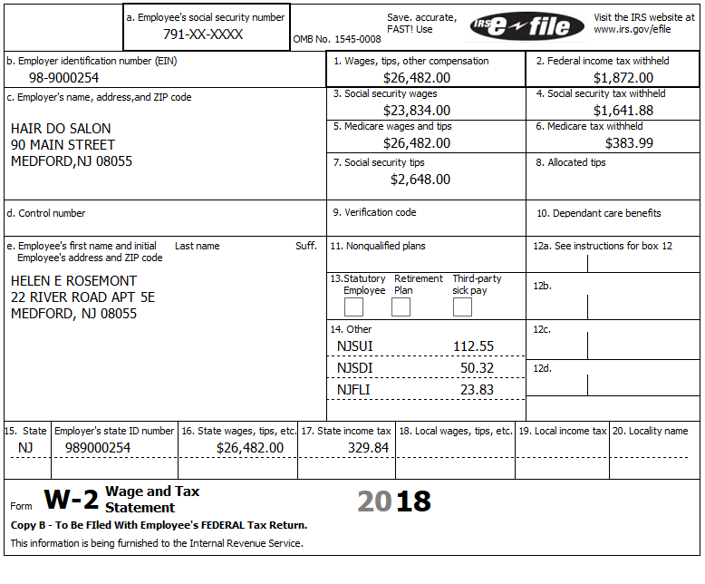

Federal AGI: 26,482 Federal Refund: 325 NJ Refund Amount: -46

Step 3 Unemployment 1099-G

TP Form / Note | TS Screen | Notes
1099-G  NJ Dep of Labor | Federal Section  Income  UnemploymentCompensation Form 1099-G Box 1 – Begin  Add or Edit a 1099-G - Begin | TS: This 1099G worksheet is for the:Taxpayer  Hint: Phone number not required  Hint: State information not required  Continue

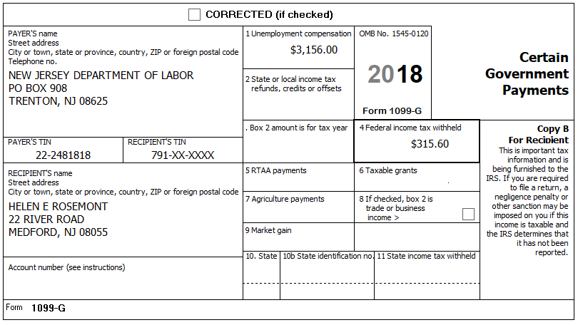

Federal AGI: 29,638 Federal Refund: 263 NJ Refund Amount: -46

Step 4 Itemized Deductions – Taxes You Paid
TP Form / Note | TS Screen | Notes
 | Left Menu  Federal Section  Deductions  Enter Myself  Itemized Deductions - Begin  Taxes You Paid - Begin | TS: Go to ADD SALES TAX WORKSHEET and enter ZIP Code and 365 days living in NJ  “Continue”

Federal AGI: 29,638 Federal Refund: 263 NJ Refund Amount: -46
Step 5 Compare Standard vs Itemized Deductions

TP Form / Note | TS Screen | Notes
 | Federal Section  Deductions  Enter Myself  Compare Deductions - Begin | Check to see if using itemized or standard deductions.  Itemized = $517  Std = $12,000  Hint: You can view Schedule A (Itemized Deductions) by clicking on the Print Icon next to Itemized Deductions in the Deductions Menu.  “Continue”
Federal AGI: 29,638 Federal Refund: 263 NJ Refund Amount: -46
Step 6 Health Insurance
TP Form / Note | TS Screen | Notes
G-Note 2 | Left Menu-Health Insurance  Health Insurance Questionnaire  Did you or your family have health insurance or qualify for a coverage exemption at any time in 2018?  Did you purchase insurance via HealthCare.gov of a State Marketplace?  Verify Your Household Members  Months Insured  Was your entire household covered by qualifying health care coverage or a coverage exemption that covered 2018 or a combination of qualifying health care coverage and coverage exemptions for every month of 2018? | Answer questions in the Health Insurance Section  TS – Yes  “Continue”  TS – No  “Continue”  TS – Always select ““Continue””  TS-Yes  “Continue”

Helen had health insurance that met Minimum Essential Coverage rules for the entire year. She did not purchase it through the marketplace. Peter is not part of Helen’s Health Household.

Federal AGI: 29,638 Federal Refund: 263 NJ Refund Amount: -46

Step 7 New Jersey Return

TP Form / Note | TS Screen | Notes
I-Note 3  G-Note 2,3,4 | State Return –Edit  Basic Information - Edit  Credits - Begin  - Property Tax Credit/Deduction-Begin | Hint: Use the NJ Checklist to enter NJ items  TS: Complete Basic Information.  Hint: Gubernatorial Election Fund: Helen -Yes  “Save  Hint: Taxpayer meets Property Tax Eligibility Requirements  Hint: Use scratch pad at TP4F to determine the proper value for Property Tax Paid  - Hint: Property Taxes Paid = (rent*.18) . (1,400*12*.18) = $3,024  TS: Answer No to question regarding you and your spouse having the same residence for 2018.  Hint: Taxpayer was not a homeowner in 2018  Save back to the beginning of the State Return

Helen has not lived with her husband, Peter Rosemont, for several years. Helen is not claiming an exemption for Peter.

Helen rents a home and pays $1,400.00/month rent.
Helen is not a Veteran.

Federal AGI: 29,638 Federal Refund: 263 NJ Refund Amount: 7

Step 8 Prepare for e-file

TP Form / Note | TS Screen | Notes
Intake Sheet  G Note 5 | Left Menu – e-file –  Federal Return Type  Fees  State Return Type  Bank Account Information  Third Party Designee Info  Consent to Disclose  Questions  Taxpayer ID Information | TS – Clear up any diagnostic messages (if any)  TS: Select “E:file: Direct Deposit”  Next  TS: No entries in Fees section except for Client email address  Next  TS: Select State Refund Type “E:file: Direct Deposit”  Next  Enter Bank Account information. The bank name is not required. Click “Pull Refund” to deposit the full amount.  Next  TS: Skip Third Party Designee. It is Out of Scope for us.  Next  TS: Consent to Disclose Tax Return Information – Check GRANT  and enter 5 digit pin (any 5 digit number) and date for TP.  Next  TS – Questions – Answer questions from Intake sheet Part VII, lines 5.6,7 and 8  - Assume taxpayer was present  Next  TS: Skip TP ID Information Screen. Not required for NJ.  Save  You are Done

She wants to handle any state refund / amount due like their federal refund / amount due

Federal AGI: 29,638 Federal Refund: 263 NJ Refund Amount: 7

